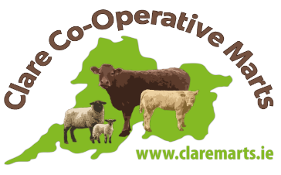
SALE OF STOCK
REQUIREMENTS

Heifers & Dry Cows must NOT be incalf.
Calves must be at least 10 days of age and under 6 weeks before they can be sold without being TB tested.
All stock must be properly de-horned.
All stock must have two complete tags.
All stock (including sheep & runners) must be PRE-ENTERED FOR ALL SALES.
There is a draw on the day to determine the first pen to be sold.
Tuberculosis Testing (TB)
All cattle 6 weeks and over including calves have to be within 12 months of TB test.
BVD
All livestock born from 1st January 2013 must be BVD Tested to be sold.
Export Testing
In order for animals to be eligible for the live export market they have to be within 30 days of TB test and must be from a complete clear herd. If animals are outside the 30 days then they can be tested by the exporter provided it is at least 42 days from their last TB test. All animals between 30 days and 42 days of their last T.B. test are not eligible for export. So when selling stock that may be suitable for export make sure they are within 30 day test or more than 42 days since their previous test. There is no need to have export certs attached to the passports as Clare Marts receives this infromation from the Department.
Sheep
All sheep including lambs presented for sale must be identified with a full set of EID tags, i.e. one conventional tag in the sheep’s left ear and a corresponding electronic tag placed in the sheep’s right ear. All sheep moved to and from a livestock mart must also be accompanied by a newly issued dispatch document containing a barcoded document serial number.
BVD SAMPLE COLLECTION: Please have your samples dropped into Kilrush Mart on Wednesday or Ennis Mart by Thursday 11am each week for collection by FBA Laboratories.

