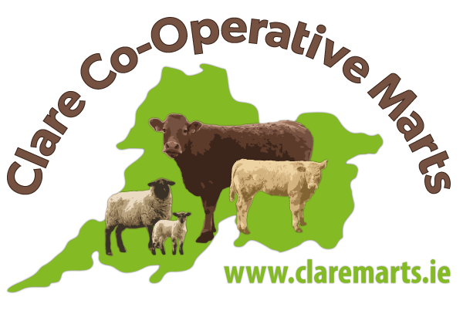

Ennis Mart
Monday 7th April 2025
Sheep Auction

Small sheep sale today with 390 sheep on offer and these met a similar trade to last week. Heay hoggets were discounted, as 52kg hoggets were as valuable as 60kg ones. Some very good hoggets available and these averaged €3.83/kg and peaked at €4.23/kg, as 14 ewes weighing 52kgs hit €220. A few entries of spring lambs and these were similar to the hogget trade. Cull ewes holding the trade very well especially the well fleshed ones, as these averaged €2.59/kg.
Hoggets
10 @ 60kgs - €221 - €3.68/kg
14 @ 52kgs - €220 - €4.23/kg
10 @ 57kgs - €218 - €3.82/kg
8 @ 54.5kgs - €215 - €3.94/kg
11 @ 40.5kgs - €166 - €4.09/kg
10 @ 49kgs - €197 - €4.02/kg

Spring lambs
3 @ 55kgs - €223 - €4.05/kg
6 @ 53.5kgs - €221 - €4.13/kg
7 @ 44kgs - €210 - €4.77/kg

